**Connect iPaaS**

**By : Akshay Hiran**

Connect iPaaS is the world's leading no-code API and data integration platform for business users and citizen integrators to automate their enterprise business processes.

#### ****The key benefits of Connect iPaaS:****

#### Quick and Easy integration with CRM, ERP, SaaS and other enterprise applications that you may already be using.

#### No-Code platform designed to solve problems of business users without the need of writing code.

#### Create pre-defined integrations and workflows (also known as recipes), which results in a faster time to market and helps you streamline business workflows and processes.

## **About Connect iPaaS**

Connect iPaaS provides drag and drop integration capabilities for SaaS applications and cloud services including, but not limited to, Microsoft Dynamics 365, ServiceNow, ADP, Office 365, Salesforce and other leading CRM, Finance, Sales and Enterprise Resource Planning (ERP) applications.

To understand it simply, when something happens in one application (Trigger), do something in another application (Action). You can also add filters to selectively process events and map dynamic data fields sourced from the applications you are integrating in your data flow.

The end user can simply pick an event or activity happening in one system and wire multiple systems to respond to that event. An example could be notifying a Slack channel when a new ServiceNow incident is created. Or, create a task in ServiceNow in response to an order logged in Salesforce, enabling a “Service Order Fulfilment” use case.

* **Login in Connect iPaaS**

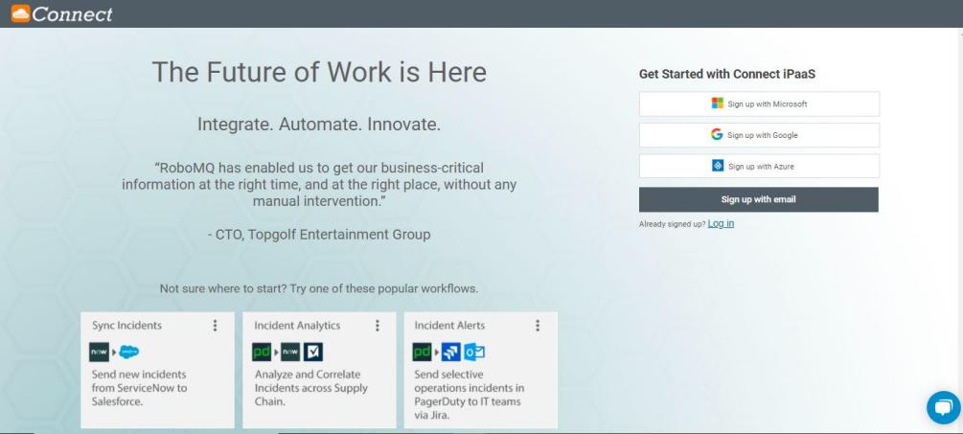Before you can create workflows in Connect iPaaS, create a trial account. Creating a trial account on Connect is easy. Simply sign up on our signup page, and fill out some basic information, or breeze through signup with one of the OAuth providers – Google, Microsoft, or Azure account.

* **Creating a Workflow using Connect iPaaS**
* **Select the Trigger Application**

Search for an application that will be the starting point of your workflow.Connect iPaaS provides integrations for applications, which are software platforms that can be on the cloud or on-premise. Every application that is available to integrate requires a connection with Connect iPaaS which can be established using the credentials you use to access the application. Below are some examples of applications that are ready to integrate in Connect. We continue to add more and more applications with each quarterly release.

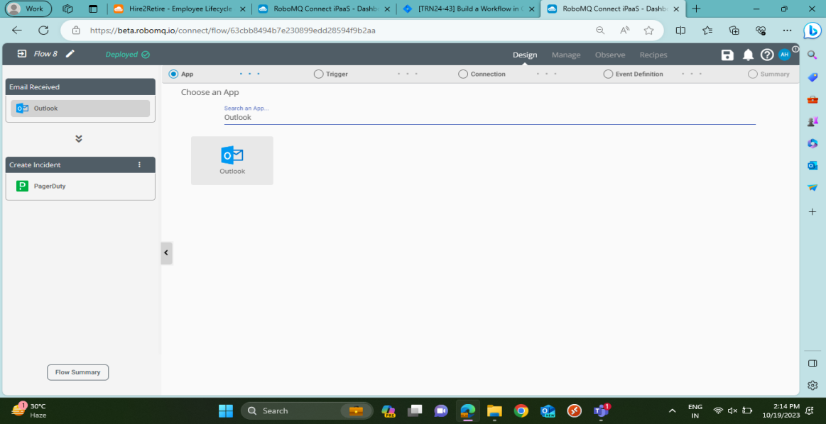

* **Process of Trigger Event**

After the connection, process will trigger event if it meets all the condition below :

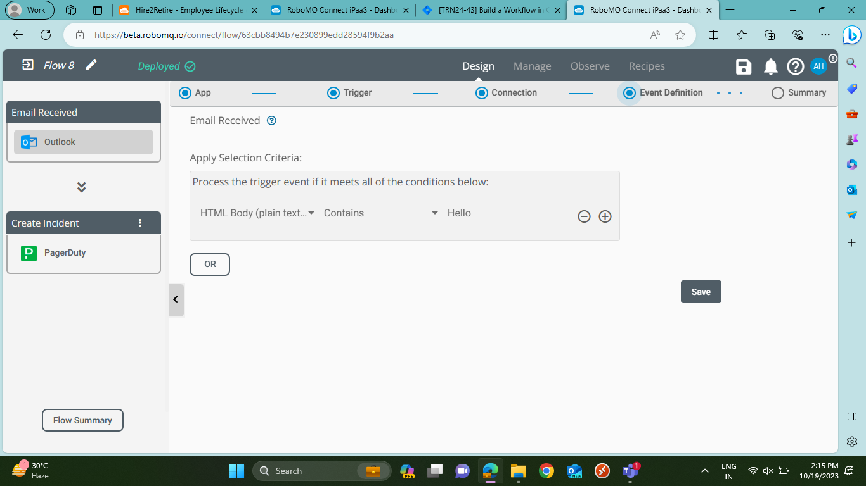

* **Event Definition**

It will describe the Definition of the Event. In which Source Application, Connection, Email Trigger, Event Filter Criteria are assigned and Deploy the Flow.

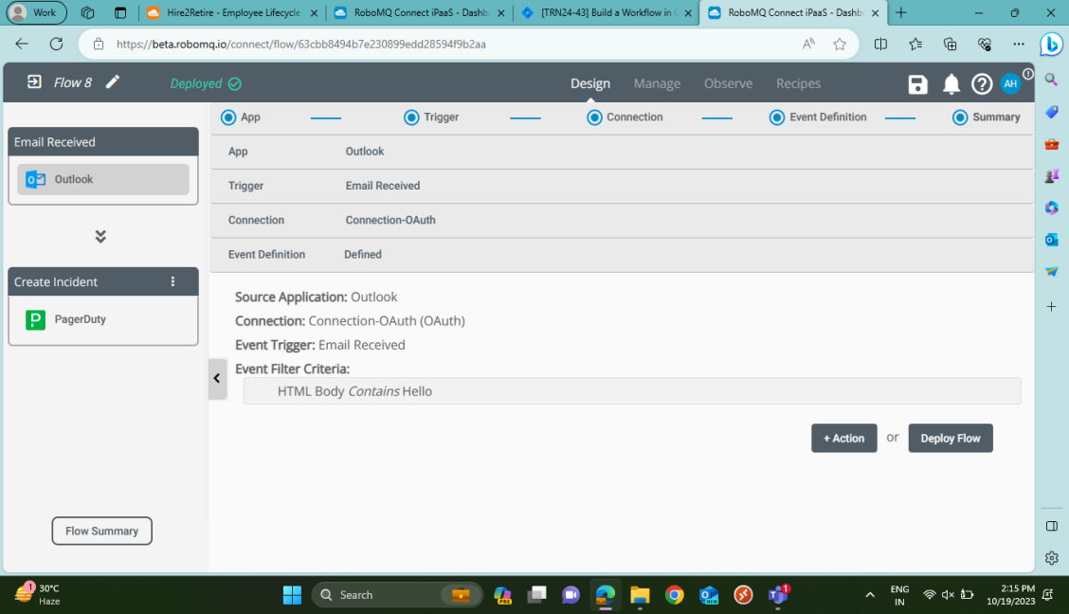

* **Trigger Phase Summary**

It defines the complete summary of the Trigger phase in which define Target Application, Connection, Action and Data Mapping and Transformation.

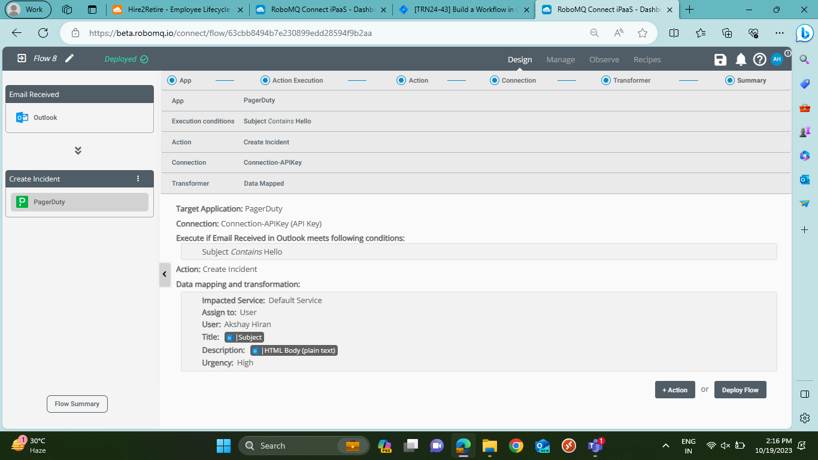

* **Choose Action Application**

Action is a response or a reaction to a trigger event. It is an activity that you perform in response to a trigger event. In the application integration context, an action can be an API call or a task performed on an application using data or characteristics of the trigger event.

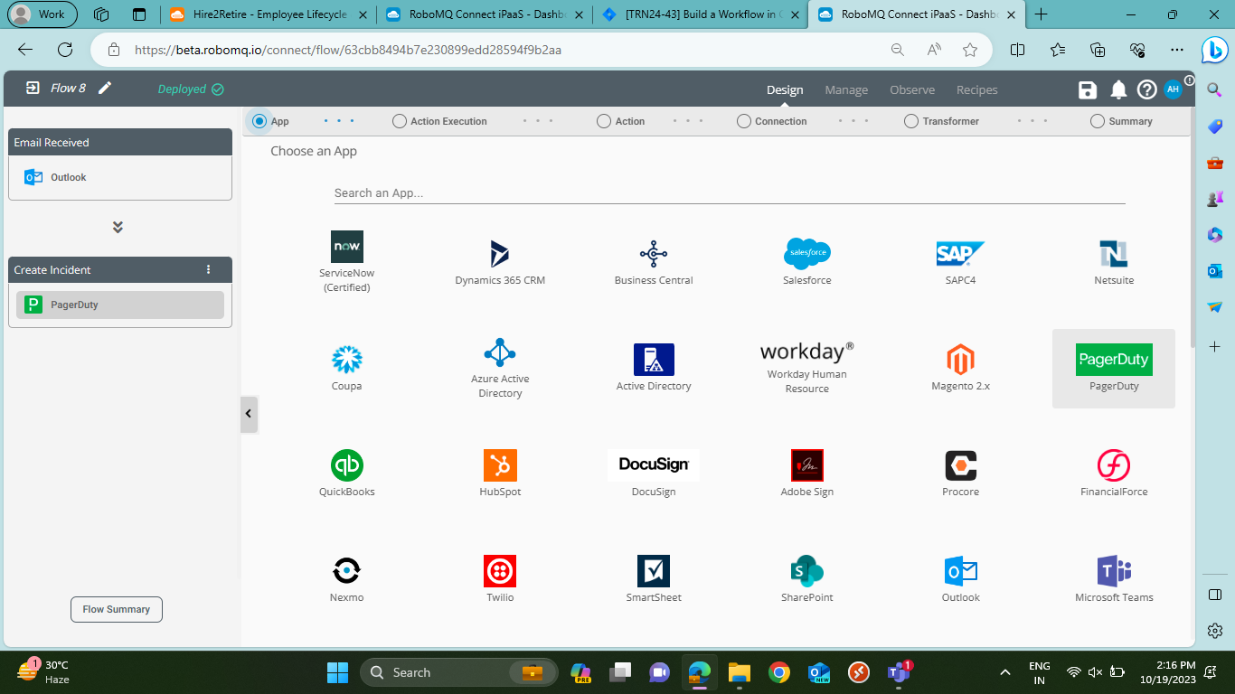

* **Apply the Condition**

You can selectively choose the events of interest to be processed by the action by applying criteria on the attributes or data fields of the events being processed. This is similar to applying if condition using more than one criteria.

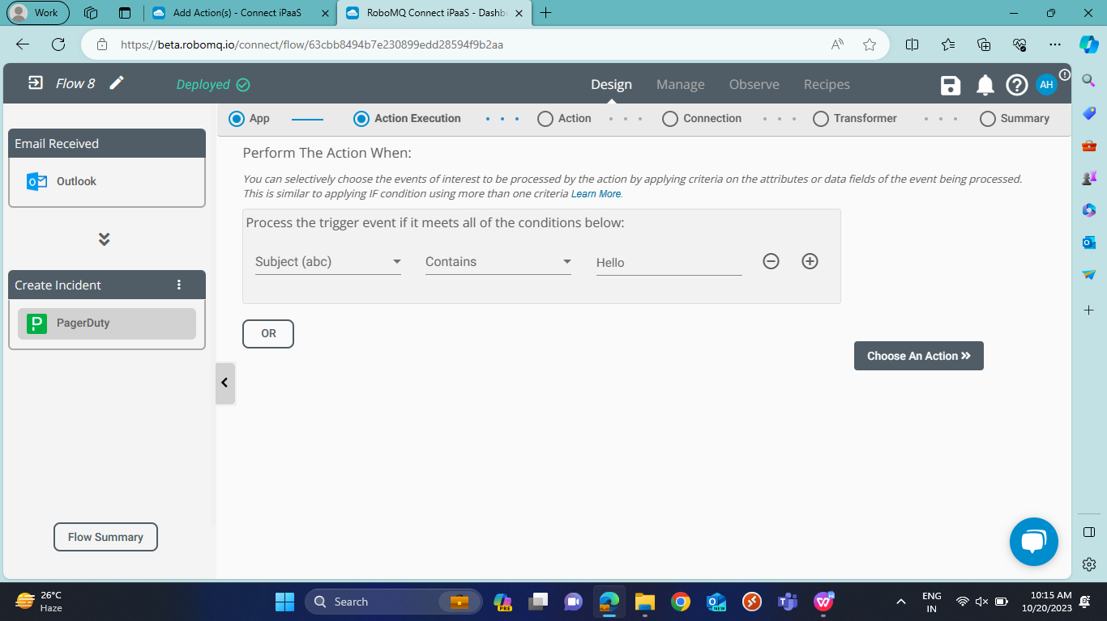

* **Choose the type of an Action**

**Create Incident :** After selecting the action as "Create Incident" as above, you can continue to configure or set up your action parameter that will define the incident in the PagerDuty application.

**Create User :** After selecting the action as “Create User”, you can continue configuring users to be created. For this, you have the option to set And or Or condition to the user fields/attributes.

**Update Incident :** After selecting the action as "Update Incident", you can continue configuring incidents to be updated. For this, you have the option to set And or Or condition to the incident fields/attributes.

**Update User :** After selecting the action as "Update User", you can continue configuring users to be updated. For this, you have the option to set And or Or condition to the user fields/attributes.

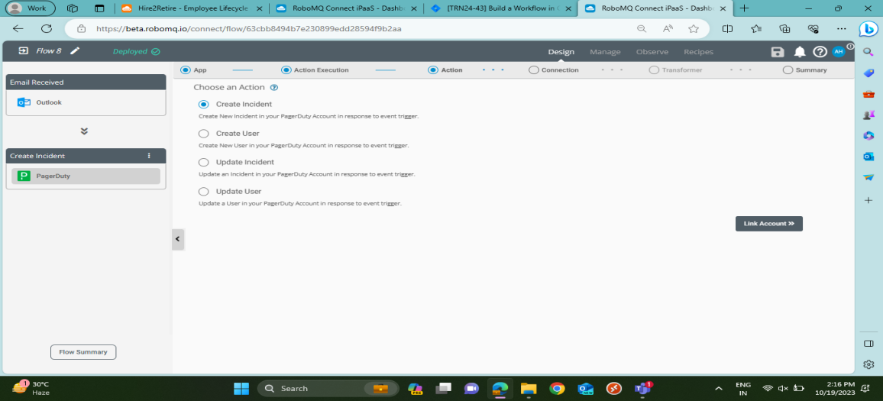

* **Set up PagerDuty action in your workflow and Transformer**

### **Create Incident :** After selecting the action as "Create Incident" as above, you can continue to configure or set up your action parameter that will define the incident in the PagerDuty application.

### **Impacted Services :** The services name that the incident is created against.

### **Assign To :**

### User - This is the user to be assigned to the new incident. If User is chosen, then a drop-down list of all users will be provided.

### Escalation Policy - If Escalation Policy is chosen, then a drop-down list of all escalation policies will be provided.

### **Title :** The name of the incident.

### **Description :** The description of the incident.

### **Urgency :** Can be High or Low.

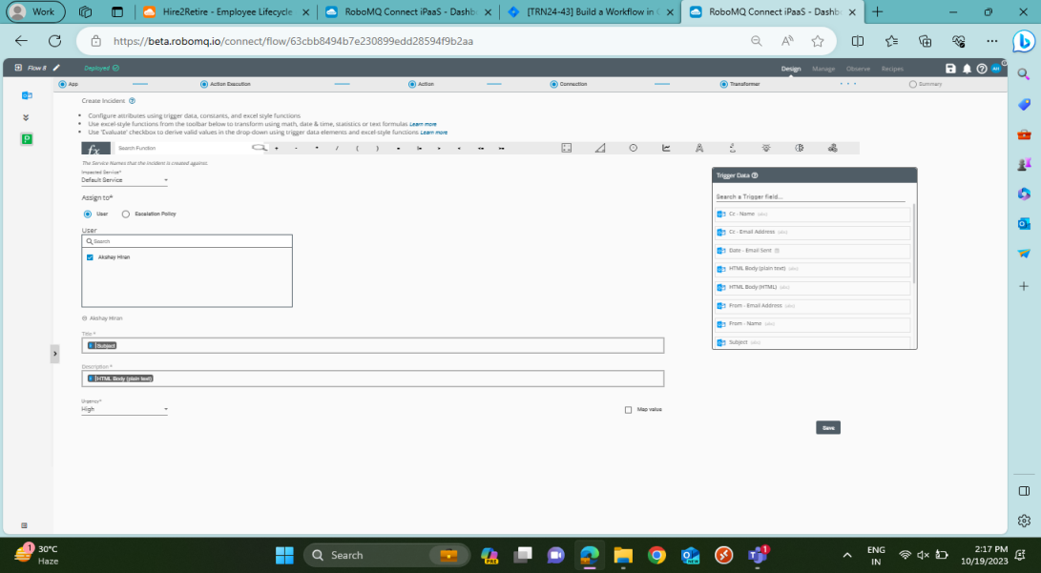

* **Deploy the Flow**

In this Phase of Action, we have to deploy the workflow, It is a summary of the complete Action Phase of the Connect iPaaS workflow.

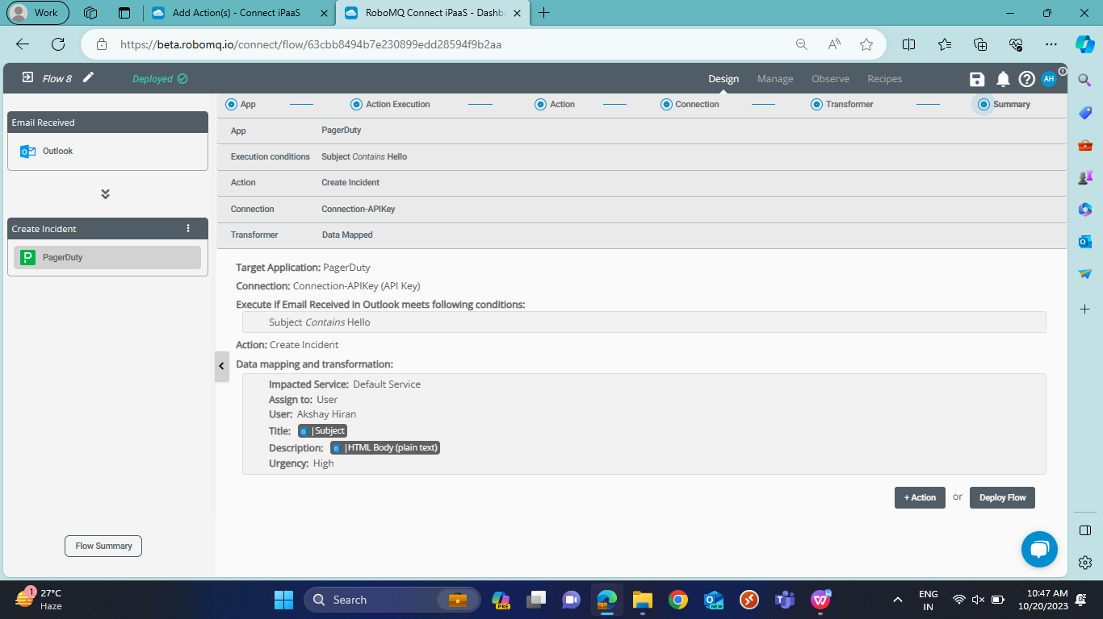

**Outcomes :**

**Step-1 :** Send the Mail through trigger Application eg. Outlook

**Step-2 :** Receive the Output mail to the Action Application. eg. PagerDuty.

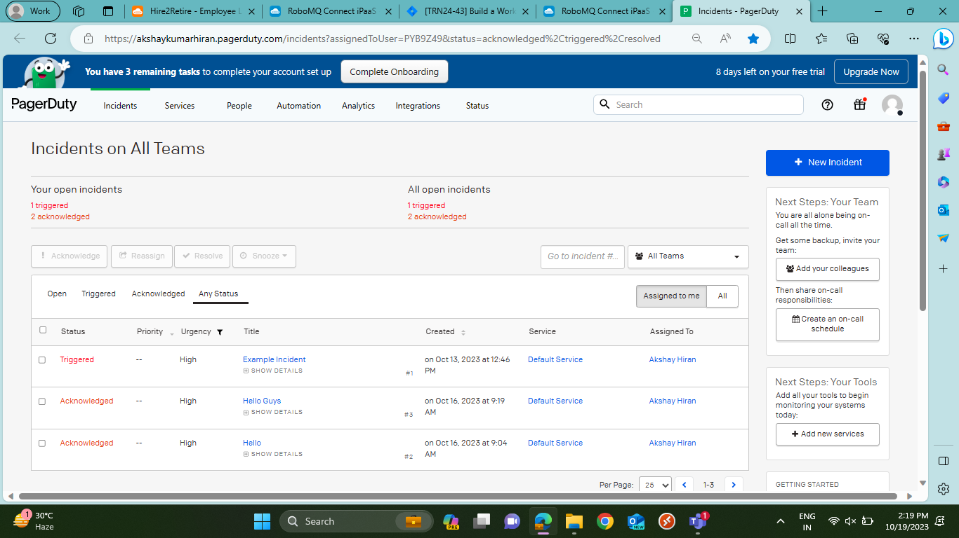

**Some Sections in Connect iPaaS**

# **Manage Pane**

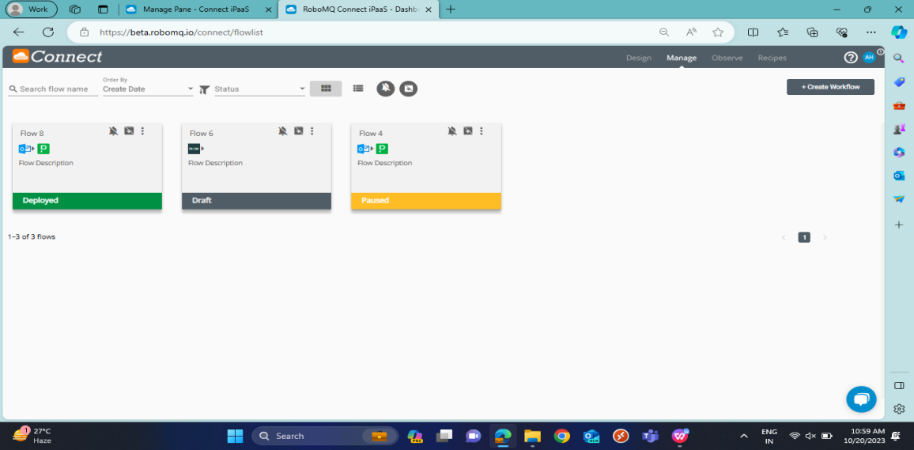The Manage tab in Connect iPaaS helps you get a birds eye view on all the workflows and manage you have pushed live or are a work in progress. On this page you can manage all your workflows including editing, share as a recipe, replicate workflows or pause them. You can also enable or disable Event Notifications via mail and/or SMS and Event Archival in your MySQL or AWS S3 database in the Manage tab.

# **Observe Pane**

On the Observe Pane you can view data about all your workflows on Connect iPaaS. It provides a simple and intuitive interface where you can view graphical and numerical information about your workflows and events.

You can use this information to check which workflows need changes so that the errors can be rectified. As an alternative, you can share this error information with your IT administrator or [RoboMQ Support team](https://docs.robomq.io/contact_form/contact_us) to seek quick help on your workflows. These details can also help business users analyze all the events processed by Connect iPaaS at one place

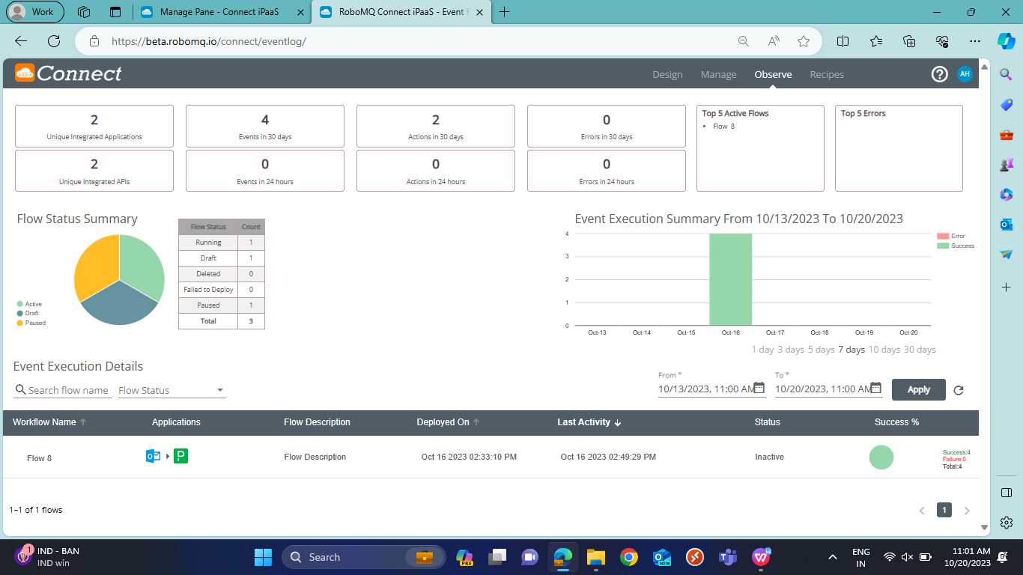

# **Recipe**

Recipes Pane on Connect iPaaS lists all the pre-built app integration workflows available for users to reuse the same for automating common business processes. On Connect iPaaS, you can find different recipes as per different business functions and applications.

